1-Etymology

📚 What is Etymology?
# Source: AI Source: Provided by: [Data Path: Persons Table -> ID Column: 1, Name_En Column: Motasem Essam] -> From: [Chatgpt (GPT-4-turbo)] on [7/23/2025]
Etymology is the study of the origin and history of words — where they came from, how their meanings and forms have changed over time, and how they were introduced into a language.

📘 Definition:
# Source: AI Source: Provided by: [Data Path: Persons Table -> ID Column: 1, Name_En Column: Motasem Essam] -> From: [Chatgpt (GPT-4-turbo)] on [7/23/2025]
Etymology is the branch of linguistics that studies the origin, evolution, and historical development of words.

🧠 Key Points:
# Source: AI Source: Provided by: [Data Path: Persons Table -> ID Column: 1, Name_En Column: Motasem Essam] -> From: [Chatgpt (GPT-4-turbo)] on [7/23/2025]
- Etymology tells us where a word came from (its root or source language).
- It shows how a word’s spelling, pronunciation, or meaning has changed over time.
- Many English words have roots in Latin, Greek, Germanic, French, or other languages.

🔍 Examples of Etymology:
# Source: AI Source: Provided by: [Data Path: Persons Table -> ID Column: 1, Name_En Column: Motasem Essam] -> From: [Chatgpt (GPT-4-turbo)] on [7/23/2025]
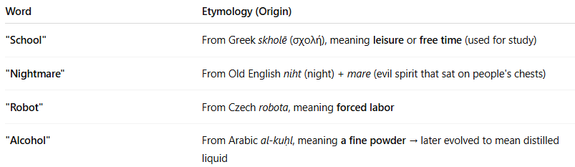
Word | Etymology (Origin)
"School" | From Greek skholē (σχολή), meaning leisure or free time (used for study)
"Nightmare" | From Old English niht (night) + mare (evil spirit that sat on people's chests)
"Robot" | From Czech robota, meaning forced labor
"Alcohol" | From Arabic al-kuḥl, meaning a fine powder → later evolved to mean distilled liquid

✨ Why Etymology Matters:
# Source: AI Source: Provided by: [Data Path: Persons Table -> ID Column: 1, Name_En Column: Motasem Essam] -> From: [Chatgpt (GPT-4-turbo)] on [7/23/2025]
- Helps understand the true meaning or hidden layers of a word.
- Useful for learning vocabulary, especially in academic and technical fields.
- Shows connections between languages (e.g., English and Latin or Arabic).

✅ Summary:
# Source: AI Source: Provided by: [Data Path: Persons Table -> ID Column: 1, Name_En Column: Motasem Essam] -> From: [Chatgpt (GPT-4-turbo)] on [7/23/2025]
Etymology is the study of where words come from and how they’ve changed over time.
It’s like the family tree of language, helping us understand the history and evolution of words.

2-Terminology

📘 What is Terminology?
# Source: AI Source: Provided by: [Data Path: Persons Table -> ID Column: 1, Name_En Column: Motasem Essam] -> From: [Chatgpt (GPT-4-turbo)] on [7/23/2025]
Terminology is the set of specialized words or expressions used in a particular field, subject, or profession. It refers to both the vocabulary of that area and the study of how those terms are used and defined.

🧠 Key Definition:
# Source: AI Source: Provided by: [Data Path: Persons Table -> ID Column: 1, Name_En Column: Motasem Essam] -> From: [Chatgpt (GPT-4-turbo)] on [7/23/2025]
Terminology is the collection of terms used in a specific domain (such as medicine, law, linguistics, science, etc.) and the study of those terms' meanings, usage, and structure.

🔍 Examples:
# Source: AI Source: Provided by: [Data Path: Persons Table -> ID Column: 1, Name_En Column: Motasem Essam] -> From: [Chatgpt (GPT-4-turbo)] on [7/23/2025]
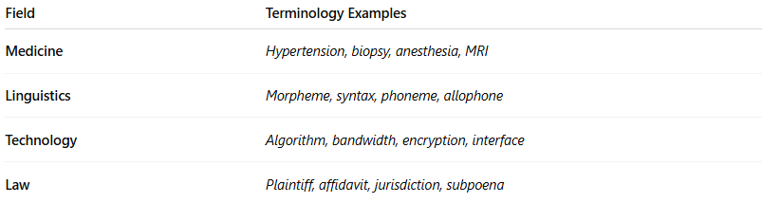
Field | Terminology Examples
Medicine | Hypertension, biopsy, anesthesia, MRI
Linguistics | Morpheme, syntax, phoneme, allophone
Technology | Algorithm, bandwidth, encryption, interface
Law | Plaintiff, affidavit, jurisdiction, subpoena

🧬 Types of Terminology:
# Source: AI Source: Provided by: [Data Path: Persons Table -> ID Column: 1, Name_En Column: Motasem Essam] -> From: [Chatgpt (GPT-4-turbo)] on [7/23/2025]
- Field-specific vocabulary: Terms only used in one area.
- General technical terms: May be used across several fields (e.g., data, system, model).
- Standardized terminology: Official terms with agreed-upon definitions (important in medicine, law, etc.).

✅ Summary:
# Source: AI Source: Provided by: [Data Path: Persons Table -> ID Column: 1, Name_En Column: Motasem Essam] -> From: [Chatgpt (GPT-4-turbo)] on [7/23/2025]
Terminology is the specialized vocabulary of a subject and the study of those words.
It helps ensure clear and precise communication within professional or academic fields.

3-Term

🔹 What is a Term?
# Source: AI Source: Provided by: [Data Path: Persons Table -> ID Column: 1, Name_En Column: Motasem Essam] -> From: [Chatgpt (GPT-4-turbo)] on [7/23/2025]
A term is a word or phrase used to represent a specific concept, idea, or object, especially within a particular field of study or profession.

📌 Key Characteristics:
# Source: AI Source: Provided by: [Data Path: Persons Table -> ID Column: 1, Name_En Column: Motasem Essam] -> From: [Chatgpt (GPT-4-turbo)] on [7/23/2025]
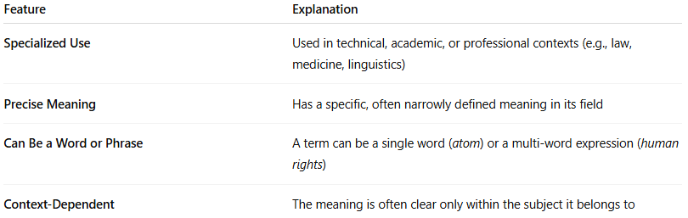
Feature | Explanation
Specialized Use | Used in technical, academic, or professional contexts (e.g., law, medicine, linguistics)
Precise Meaning | Has a specific, often narrowly defined meaning in its field
Can Be a Word or Phrase | A term can be a single word (atom) or a multi-word expression (human rights)
Context-Dependent | The meaning is often clear only within the subject it belongs to

🧠 Examples of Terms in Different Fields:
# Source: AI Source: Provided by: [Data Path: Persons Table -> ID Column: 1, Name_En Column: Motasem Essam] -> From: [Chatgpt (GPT-4-turbo)] on [7/23/2025]
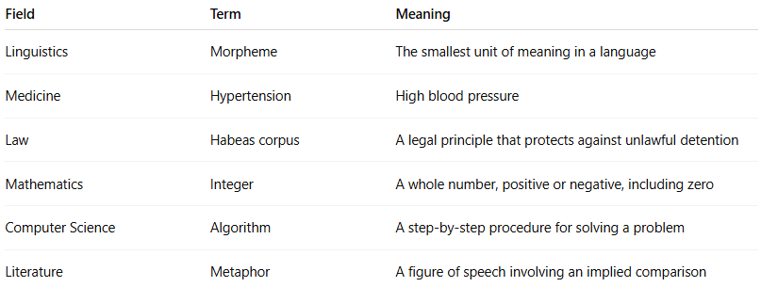
Field | Term | Meaning
Linguistics | Morpheme | The smallest unit of meaning in a language
Medicine | Hypertension | High blood pressure
Law | Habeas corpus | A legal principle that protects against unlawful detention
Mathematics | Integer | A whole number, positive or negative, including zero
Computer Science | Algorithm | A step-by-step procedure for solving a problem
Literature | Metaphor | A figure of speech involving an implied comparison

🔄 Term vs. Word:
# Source: AI Source: Provided by: [Data Path: Persons Table -> ID Column: 1, Name_En Column: Motasem Essam] -> From: [Chatgpt (GPT-4-turbo)] on [7/23/2025]
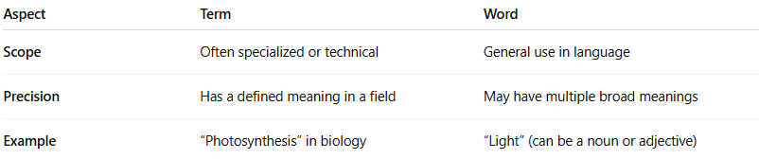
Aspect | Term | Word
Scope | Often specialized or technical | General use in language
Precision | Has a defined meaning in a field | May have multiple broad meanings
Example | “Photosynthesis” in biology | “Light” (can be a noun or adjective)

Relation Between Term and Terminology:
# Source: AI Source: Provided by: [Data Path: Persons Table -> ID Column: 1, Name_En Column: Motasem Essam] -> From: [Chatgpt (GPT-4-turbo)] on [7/23/2025]
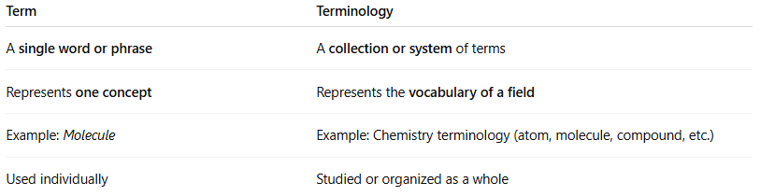

Term | Terminology
A single word or phrase | A collection or system of terms
Represents one concept | Represents the vocabulary of a field
Example: Molecule | Example: Chemistry terminology (atom, molecule, compound, etc.)
Used individually | Studied or organized as a whole

✅ Summary:
# Source: AI Source: Provided by: [Data Path: Persons Table -> ID Column: 1, Name_En Column: Motasem Essam] -> From: [Chatgpt (GPT-4-turbo)] on [7/23/2025]
A term is a specific, precise expression used in particular domains to clearly convey meaning, especially in academic, scientific, or professional settings.

